The analysis of hydraulic tests of pipes with defects, reinforced with composite bandage.

Dmytriienko Roman (Дмитриенко Р. И.), e-mail dri1@ukr.net
(E. O. PATON EWI, Kiev).

Task 4.2 (E. O. PATON EWI): To produce a full-scale pipe specimen with the composite wrap over artificial VSD. The specimen will be prepared according to the input data from WP3, experimental data from Task 4.1 and taking into consideration the requirements of ISO/TS 24817.

Keywords: pipe, defect, bandage, internal pressure, strain, test.

Various types of defects in pipelines are subjected to repair using composite bandages, but a significant part of all detected defects are not crack-like defects of erosion-corrosion origin. The purpose of repair is to protect against further corrosion in the defect, in the case of a defect on the outer surface and the restoration of the bearing capacity of the damaged section of the pipeline. To make pressure of the destruction of the repaired area not lower than the pressure of the fracture of defect-free section of the pipeline, it is necessary to assign the correct thickness of the bandage, but it should not be too large. For this purpose it is necessary to consider working the tube with defect and bandage together up to the limiting condition, i.e., take into account the plastic deformation, which significantly alter the distribution of stress in the defect and the bandage.

Statement, goals and objectives of the conducted hydraulic tests.

The sample modeling the damaged pipe repaired using composite bandage was subjected to the hydraulic tests with internal static pressure (see. Fig. 1). For the basis for the manufacture of sample was taken a hot-rolled seamless pipe 219×6, made of steel 20 fabricated in accordance with the nm [1, 2], at JSC "Interpipe NTZ", Dnepropetrovsk, Ukraine. The sample was welded flat bottom.

On the sample by mechanical means a defect was made - a model of 60% flow-accelerated corrosion (FAC). The relative geometric parameters of the defect were taken according to [3, 4]. The shape of the defect is chosen very well, a significant portion of the same thin places allows to fully realize the plastic deformation in an extensive area of the defect, which gives the opportunity to measure them. The formation of the bandage of thickness of 6.22 mm (16 layers) on the sample was done by machine winding of roving consisting of filaments of glass type "E" [5], wetted in epoxy binder of hot curing [6]. Laying of the roving was made at the angle ≈ 90 ° to the pipe axis. The bandage was formed in layers. The bandage overlapped the defect in the axial direction. After stacking, the bandage was polymerized at high temperatures. In order to align the geometric shape of the tube and the force transfer from the outer surface of the defect to the inner surface of the bandage, the defect was filled first with compound consisting of roving cut into pieces mixed in a cold curing epoxy binder [7]. The bandage was set after polymerization of the compound. Before hydrostatic tests, strain diagrams have been obtained and the mechanical properties of the pipe material were identified, the maximum deformation and the maximum force that can take the roving out were determined, as well as in the ingredients of the composite material of the bandage. An ultrasonic method was used to determine the wall thickness in the regular part of the tube and into the defect area and perimeter was measured. Based on these data, given the winding step, the required number of layers of bandage was calculated.

The main objective of this work was to determine the minimum number of layers of bandage that meets the following requirements and experimental verification of compliance with these requirements.
- when testing the pressure after installing the bandage, in the defect there should be no plastic deformations.
- the destruction of the sample should occur not at the repaired area, i.e. the bearing capacity should be fully restored.
- while the destruction of a sample the defect must contain the measurable permanent plastic deformation, but below the limit of deformation for the material of the bandage.
- after winding of the bandage, and after pressure relief, when the metal of the tube has undergone plastic deformation, there shall be no buckling of the cylindrical wall of the pipe from external pressure on the pipe created by the bandage.

When conducting field tests there were studied elastic and plastic deformation of defect reinforced by the bandage.

To determine the level of residual plastic deformations after the destruction of the sample and removal of the bandage, in the central part of the outer surface of the defect in circumferential and axial directions the bases were selected. The base was a distance between the points obtained by punching. The distances between punched points were measured with a metal flexible ruler.

Prior to the installation of compound and bandage, in the central part of the outer surface of the defect in circumferential and axial directions, the strain gauges were glued to measure the full and residual deformations. The strain gages (s/g) were also installed and in regular parts of the sample, they were located in the same cross-section where the defect was located, but shifted by ~ 120 deg from it. After installing the bandage, the s/g were glued, but they were not located strictly above the s/g glued on the metal of the pipe, but several of them were displaced on more smooth areas. When measuring resistances of the strain gauges on the bandage, the readings from sensors surviving under the bandage after the temperature polymerization were taken. Deformation was measured under load and after its relief. Total deformation under load was calculated taking into account the residual deformation of the previous stages. All the glued strain gages were duplicated.

Hydraulic loading of the sample with internal pressure were produced by the pump at a constant rate. The loading took place by stages. Pressure on each stage was increased from zero to some maximum value, which exceeded the maximum pressure of the previous stage. Then the holding pressure took place, during the initial stages for withdrawals of readings of strain gauges, to follow, to the full realization of plastic deformation. After exposure, the pressure was dropped to zero. At the end of each stage the weight of the sample and outer perimeters in several sections of the bandage and the pipe not covered with the bandage were measured. After the installation of strain gauges on metal, there have been several stages of loading by internal pressure. After s/g as a defect in the annular direction started to fix the residual deformation the bandage was set, and the loading was resumed. Loading was performed until destruction (depressurization) of the sample (see figure 4a).

The tests were carried out in an accredited laboratory of hydraulic tests of welded products of the Institute of electric welding named after E. O. Paton, Kiev, Ukraine, in the framework of research under the 7th EU framework programme "INNOPIPES". The test results of this sample were compared with the results of the tests of the other three samples made on the basis of the same pipe. The samples consisted of: the portion of the undamaged pipe, part of pipe with the same defect and the intact portion of the pipe completely covered with a bandage of the same material as the bandage of the considered sample.

a
b
c
d
Fig. 1. Preparing a full-scale model.
a - prior to installation of strain gages and bandage; b - installation of strain gages in the defect; c - the defect filled with strain gages compound, d - sample with the bandage and strain gages.

The results of the research.

Fig. 2 shows the results of measurement of the deformations of the pipe in the defect area and the regular area, before installing the bandage, and after its installation. Loading without bandage was held up to the pressure at which there appeared permanent deformation in the defect in the annular direction. The figure also shows the deformation of the bandage. For comparison, Fig. 2 shows a similar deformation of the sample (of the same pipe and the same defect), but which is tested without installation of the bandage.

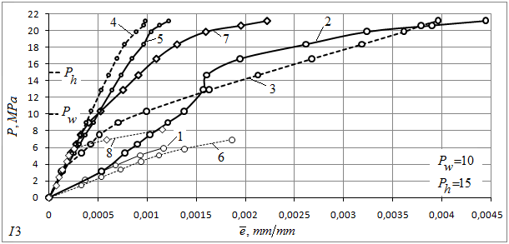
Fig. 2. The deformation of the sample during the initial stages of loading.
Ring strain: 1 - in the defect prior to installation of the bandage, 2 - after; 3 - bandage in the defect area, 4 - in the regular area; 5 - the pipes in a regular zone; 6 - in the defect of the similar sample. Axial deformations: 7 - in the defect after installation of the bandage; 8 - in the defect of similar pattern. P_{w}, P_{h} - accepted working and test pressure.

Installing the bandage on the sample had no effect on the initial part of axial strain in the defect, which also coincides with the same area of the sample with defect and without a bandage. Axial deformation of the bandage over the defect coincide with the axial deformations of the defect. When deformation of ~ 0.1% the sensor has failed in all probability because of cracking. After installation of the bandage circumferential deformation in the pipe were slightly decreased. The dependence of the circumferential deformations of the regular part of the pipe from the pressure in Fig. 2 is not representative because the strain gages were installed in the local place, and their indications are very influenced by the ovality of the pipe.

In the area of the defect enabling the bandage to the work starts not immediately but after some minor deformation after selecting the possible gaps between the defect and the compound, the compound and the bandage and within the compound, and the bandage. Then the stiffness in the circular direction of the defect and accordingly, the pressure of fluidity in the defect increased significantly.

Fig. 3 shows the diagram of loading of the sample internal pressure to rupture. Loading was done in stages. The stages are shifted along the abscissa so that the beginning of the plastic zone coincides with the end of the plastic zone of the previous stage.

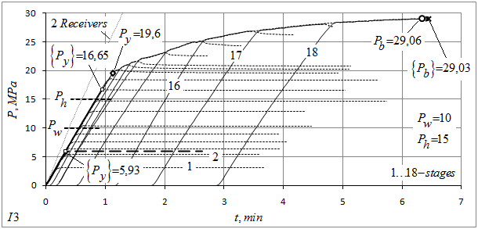
Fig. 3. The diagram of loading of the sample with internal pressure to destruction.
P_{w}, P_{h} - accepted working and test pressure; {P_{y}} - total yield stress defined by an annular strain gages in the defect; P_{y} - total yield stress defined as the breaking point of the diagram of loading by internal pressure; P_{b}, {P_{b}} - the maximum pressure that the sample sustained, and the pressure at which the destruction occurred; 2 Receivers - chart of loading of two paired receivers without test object; thick dashed line - the last (5th) stage before installation of the bandage; thin dashed lines - shutter speed on the stages.

Fig. 3 shows that the pressure at which a residual deformation in the circumferential direction of the defect after the installation of the bandage begin to appear, significantly increased from 5,93 up to 16,55 MPa, which is higher than the test pressure. The same pressure, but for the sample tested without a bandage until the destruction amounted to 5.83 MPa.

Maximum pressure that withstood a sample made of the same pipe, but with no defect and bandage amounted to 27.59 MPa, hence it can be concluded that the bandage fully restored carrying capacity of the pipe with a defect. For example, the actual burst pressure of sample with defect and without bandage amounted to13.83 MPa.

In determining the minimum number of layers of bandage satisfying the above requirements, the following provisions were used.

Because the pipe material in contrast to the material of the bandage is not elastic until destruction, to describe the joint work of the pipe and bandage down to a limiting condition it is necessary to use the theory of plasticity.
Considering the steel pipe without defect installed on the bandage, the ratio of axial stress to circumferential stress in the pipe is not constant, i.e. the loading is not simple. In this case, it is possible to apply the dependence theory of plastic flow, but the effect of Baushinger is neglected [8]. As a reference calculation more convenient, deformation theory of plasticity can be used, which is used to describe simple loading. It should be noted that the decisions on these two theories appear to be close. Assuming that the bandage does not resist in the axial direction of the pipe, the task is greatly simplified. Collaboration solution of elastic, working in one direction bandage and elastic-plastic pipe described in [9]. The solution to the problem of plastic deformation of defect under the bandage is very time consuming, so in determining the required number of layers of bandage the following was decided. Because the material of the bandage unlike to the pipe material has small marginal deformation, and the dimensions of the defect are not small, then the solution to the problem of plastic deformation of the pipe with a defect and a bandage was used, the solution of the problem of defect-free pipe with bandage, pipe wall thickness was taken of the wall thickness in the defect. The validity of this view is confirmed by test results. Before test this sample there was tested defect-free sample with bandage of the same material, arranged with the same pitch, but having 8 layers. The maximum pressure amounted to 39.65 MPa. The research results of the joint work of defect-free pipe with bandage provided the basis in the appointment of the thickness of the bandage on the sample with defect.

Figure 4 shows the full-scale sample after the testing with internal hydraulic pressure until destruction. The destruction took place on the pipe section not covered with the bandage. In accordance with the requirements to the surface of the fracture and form a line of depressurization, by pressure tests to destruction as specified in [10], and given the lack of debris, the collapsed sample was viscous.

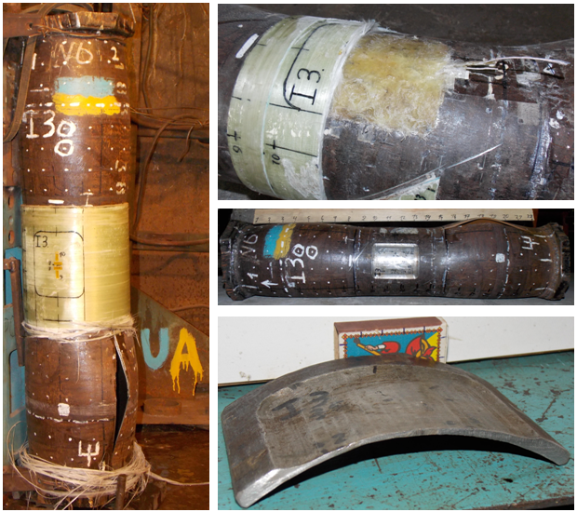
a
b
c
d
Fig. 4. The sample after the test.
a - sample after destruction by hydraulic pressure; b - opening of the defect; c - after removal of bandage; d - cut part of the defect.

The ultimate deformation at which there is a destruction of the bandage, is 1.4 %. After removing the bandage, circumferential residual strain in the defect was 1.33 %, which shows that the bandage in the area of the defect was close to its limit state. Residual circumferential deformation of defect-free sample area covered by the bandage was ~ 0.2% and uncovered the bandage ~ 11 %. Note that after destruction the residual circumferential deformation in the defect when testing a similar sample, but without bandage was 5.2 %.

It is interesting to note that the elongation of the base in the axial direction of the defect after the destruction of the sample is not fixed, that may be indicative of a lack of plastic deformation stretching of the defect in the axial direction, the same applies to the sample with defect and without bandage. Residual deformation of the outer surface in the axial direction of the defect, of course, exist, but that is the flexural deformation. As can be seen from Fig. 2 - dependence of the axial strain from the pressure changes the angle, when the annular direction of the defect plastic deformation begins.

Conclusions.

1. The tests indicate that the presence of the bandage reduces the level of circumferential stresses in the defect, but the bandage does not start to work immediately.
2. The presence of the bandage, due to the increased rigidity of the defect, increases the pressure of the viscousness in the defect.
3. Because the roving-laying occurred at an angle close to 90 ° to the pipe axis, the bandage does not work in the axial direction.
4. The thickness of the bandage is designed in such a way as to fully restore bearing capacity of the damaged pipes.

Bibliography.

1. GOST 8732-78. Seamless hot deformed steel pipes. Assortment.
2. GOST 8731-74, p.1.2.In. Seamless hot deformed steel pipes. Technical requirements.
3. API 579-1/ASME FFS-1 Fitness for Service.
4. Zecheru Gh., Yukhymets P. S., Dumitrescu A. and Dmytriienko R. Development of an Experimental Programme Aimed at Emphasizing the Consolidation Effects of Composite Material Wraps Applied for the Repair of Transmission Pipelines with Volumetric Surface Defects. - In: Proceedings of the XXIX International Conference “NDT 2014” (Sozopol, Bulgaria), 2014, 535-539.
5. GOST 17139-2000 - Fiberglass. Rovings. Specifications. Minsk.
6. TU 24.6-0030314547-002-2004. Epoxy binder brands KDA-HI.
7. Universal epoxy glue brand "Himcontact - Epoxy ", TU-U 24.6-2558309112-006-2006.
8. Malinin N. N. Applied theory of plasticity and creep. Textbook for University students. Ed. 2nd, Rev. and supplementary M., "Engineering", 1975. - 400 p. with ill.
9. Obraztsov I. F., Vasilyev V. V., Bunakov V. A. Optimal reinforcement shells of revolution made of composite materials. M., "Engineering", 1977, 144 p.
10. ISO 9809-1:2010(E). Gas cylinders - Refillable seamless steel gas cylinders - Design, construction and testing - Part 1: Quenched and tempered steel cylinders with tensile strength less than 1100 MPa.

Roman Dmytriienko.
Contact information: e-mail dri1@ukr.net, mob. +380688579600.

Posted online 12/24/2015 Mr.

