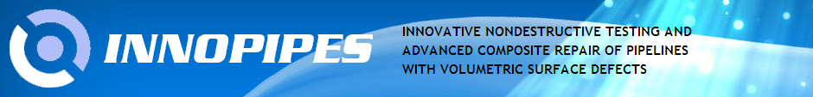
 |  | 
Seventh Framework Programme  Marie Curie Action "International Research Staff Exchange Scheme" |  | Paton Welding Institute  Kiev, Ukraine

Protocol of composite material and its components test

Contents
 | p.
1. The material of the reinforcing element and the resin | 2
2. Preparation of the tensile test specimens of the composite material | 4
3 The test results of the composite material | 6
4. The tensile test of the roving | 11
5. Comparison of test results of the roving and the composite material | 13
6. Additional research of the material | 14
7. Properties of the filler material | 16
8. List of references | 16

Roman Dmytriienko dri1@ukr.net, www.dri1.cc.ua April 2015
1. The material of the reinforcing element and the resin

As the reinforcing element is used straight roving (fig. 1) from fiberglass ЕС 10 1680Н-У10(168) [2], as the filler - epoxy resin КДА-ХИ [1]. Here and further in the text of the Protocol, the roving – is the single strand of fiberglass, consisting of ~ 1200 filaments.

Table 1. The results of roving ЕС 10 1680Н testings1)
№ | Parameter | ЕС 10 1680Н-У10(168)³⁾ | ЕС 10 1680Н-У11(168)
1 | Linear density, teks | 1760 | 1748
2 | Moisture content,% | 0.02 | 0.02
3 | Substances deleted during roasting,% | 1.0 | 0.81
4 | Unit breaking load, mN/teks²⁾ | 599.1 | 653.4
Notes:
¹⁾ Tested on 28.04.2005 by " Объединение стеклопластик " Ltd according to [4, 5]. For winding was used the roving ЕС 10 1680Н-У10(168) with the lubricant У10, the results of the roving in combination with lubricant У11 are given for reference;
²⁾ 1teks = 1 g/1 km;
³⁾ Designation of the roving according to [2]: E - general purpose glass; C - continuous thread; 10 - nominal diameter of elementary filament, μm; 1680 - nominal linear density, teks; Н - for winding; У10 - lubricant; 168 - linear density of complex threads, teks.

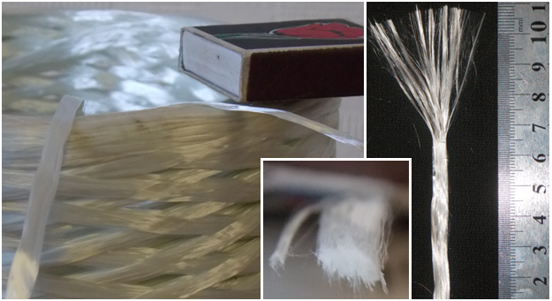
a
b
c
Figure. 1. The roving used as the reinforcing element: a - roving, laid in the reel; b - cross section of roving; c - the end of the roving in free state.

According to [2] minimal unit breaking load of the roving: 396 mN/teks (40 g/teks).

Theoretical breaking load is calculated as the product of the linear density and the unit breaking load:
У10: 1760 × 599.1 = 1054416 mN = 1054.416 N = 107.5205 kgf.
У10: 1748 × 653.4 = 1143891 mN = 1143.891 N = 116.6444 kgf.

Table 2. Characteristics of epoxy resin КДА-ХИ according to the certificate¹⁾
№ | Characteristic | According to [1] | Actually
1 | Appearance | Homogeneous liquid of medium viscosity, from light yellow to light brown color without mechanical inclusions and clots
2 | Viscosity by viscometer VZ-246 (6 mm nozzle diameter) at 25 ± 2 ºC, min | 0.5-2.0 | 0.1
3 | Gel time (sec) of 2 grams at temperature:  180 ± 2 ºC  160 ± 2 ºC | 50-105  80-120 | 94
Note:
¹⁾ Date of manufacture 7.04.2005, warranty period - 12 months.

Manufacturer's information (NPP «Synthesis», Donetsk) on the strength characteristics of the polymer matrix of the resin КДА-ХИ after the standard mode curing (100…180 ^{о}С during 2 hours):
-flexural strength - 90...110 MPa;
-tensile strength - 75...80 MPa;
-impact strength - 5...10 Kj/mm²;
-elongation - 5.5...8%.

Additional information.

- after winding on a cylindrical pipe the roving cross-sectional dimensions typically are 3×0.3 mm;
- after winding on tube with a diameter of 320 mm the density of filling was 0.7...0.72;
- the tension of the roving with force > 5 kg results in breaking of some filaments;
- filling density is defined as the ratio of the weight of glass it has after thermal removal of the resin at a temperature of 400…450 ^{о}С during 2…3 h, to the initial weight of the material;
- polymerization of composite repair after its installing is done at a temperature of 120…180^{о}С. The same temperatures was used for polymerization of composite test specimens.

2. Preparation of the tensile test specimens of composite material

To determine the mechanical properties of the composite material specimens in form loop were manufactured. Specimen consisted of two branches, a and b (fig. 2, 3). The loop formed by winding the roving, soaked with epoxy, on special rig (fig. 2a, 2e). During the winding the roving was stretched by applied force. (table 3).

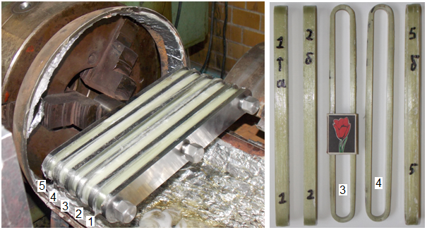
a
b
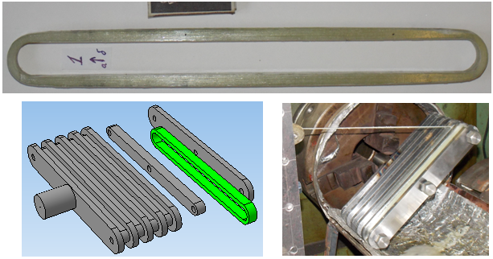
c
d
e
Figure. 2. Preparation of the tensile specimens: a - loops 1... 5, wrapped up in a snap; b - specimens of П1…П5 before the test; c - sample П1; d - model of used rig; e - winding loops on the rig.

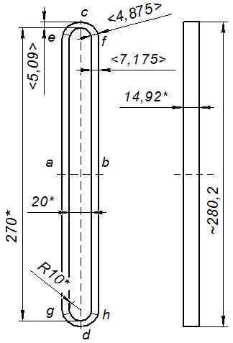
Figure. 3. The geometrical dimensions of the tensile specimen: * - dimensions are the same for all specimens; < > average size; (a), (b), (c), (d), (e), (f), (g), (h) - sections of specimen.

Table 3. Characteristics of tensile specimens.
Specimen |  |  | П1 | П2 | П3 | П4 | П5 | Average
¹⁾ Preliminary tension of roving, |  |  | 2 | 4 | 3 | 3.5 | 0.1 | 2.5
²⁾ number of turns of the roving |  |  | 80 | 80 | 80 | 80 | 75 | 79
width of the section, mm | (a) |  | 7.3 | 6.8 | 6.7 | 7.0 | 8.0 | 7.2
width of the section, mm | (b) |  | 7.1 | 6.8 | 6.5 | 7.0 | 8.6 | 7.2
width of the section, mm | (c) |  | 4.9 | 5.1 | 5.3 | 4.9 | 5.2 | 5.1
width of the section, mm | (d) |  | 4.9 | 5.0 | 4.9 | 5.2 | 5.5 | 5.1
width of the section, mm | round place | (e) | 4.8 | 4.6 | 4.8 | 5.0 | 5.0 | 4.9
width of the section, mm | round place | (g) | 4.9 | 4.7 | 4.7 | 4.9 | 5.0 | 4.9
width of the section, mm | round place | (f) | 4.9 | 4.7 | 5 | 4.8 | 5.0 | 4.9
width of the section, mm | round place | (h) | 4.9 | 4.6 | 4.7 | 5.0 | 5.5 | 4.9
Fracture location |  |  | (g) | (f) | (e) | (e) | (g)
Notes:
¹⁾ average value, amplitude variation during winding ± 1.5 kg;
²⁾ number of turns may vary ± 3.
3. The test results of the composite material

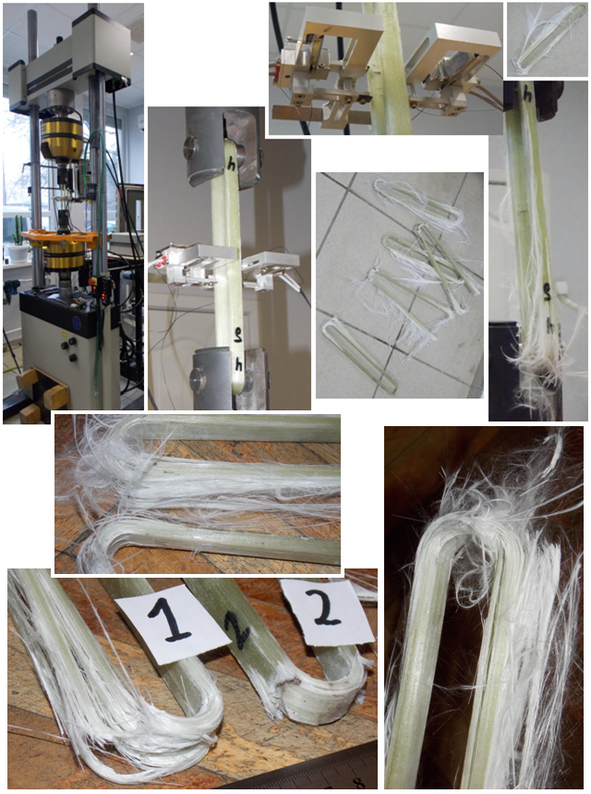
a
b
c
d
e
f
j
g
h
Figure. 4. Tensile test: a - testing machine Instron 8802; b - specimen gripping; c - extensometer Biaxial 2620-614; d, e, f, j, g, h - features of specimens fracture.

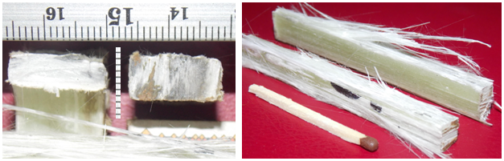
1
2
a
b
Figure. 5. Specimen П4 after the destruction: a - cross section (1 – at the section c, 2 - at the section a, (see Fig. 3); b - longitudinal splitting of branche a (see Fig. 3).

Table 4. Results of tensile tests¹⁾.
Specimen | П1 | П2 | П3 | П4³⁾ | П5 | Average
stress of fracture, kN | 95.28 | 101.23 | 99.19 | 96.04 | 99.87 | 98.32
max. strain,% | 1.36 | 1.44 | 1.59 | 1.39 | 1.58 | 1.47
Poisson's ratio µ | 0.179 | 0.196 | 0.164 | - | 0,147 | 0.172
²⁾ Young's modulus, E, MPa | 32721 | 34645 | 31673 | 33079 | 25518 | 31527
²⁾ tensile strength, MPa | 445.0 | 498.9 | 503.6 | 459.8 | 403.2 | 462.1
Notes:
¹⁾ Longitudinal and transverse base of was - 25 mm and 15 mm, respectively. Test temperature + 20 ^{о}С , speed of deformation 10 mm/min.
²⁾ The thickness in the middle part of the loop was used in the calculation of the mechanical properties of composite;
³⁾ During the test, the shift of the extensometer had occurred.

In Figure 6 are given examples of the specimen П2 tension.

From fig. 6d we can see that stress F₁, per one roving, almost in proportion to the longitudinal deformation, so after removing of the extensometer the destruction deformation can be found by linear continuation of relation up to ultimate load on one roving.

Summary of the test results of specimens П1…П5, given to the force on 1 roving, are presented in Figure 7.

It should be noted that dependence of the destruction and ultimate deformation on preloading of the roving was not detected (fig. 8).

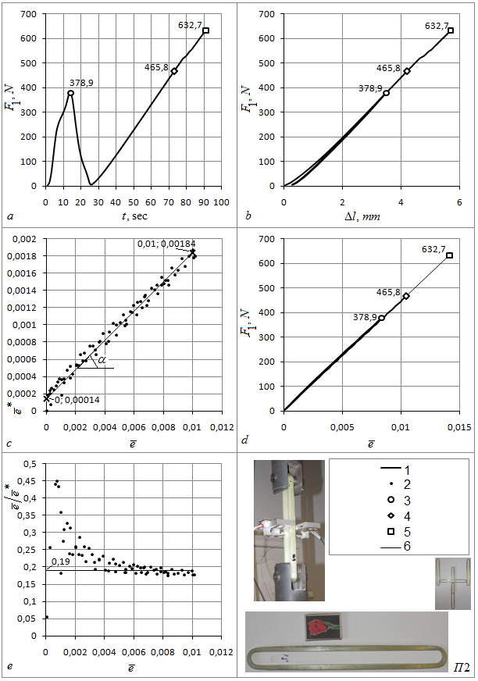
Figure. 6. Tension of the specimen П2: a, b, d - dependence of force per 1 roving (F₁) from time (t), displacement of grips (Δl) and strain (), respectively; c, e - transverse strain () and ratio () depending on the longitudinal deformation (). 1, 2 - test results; 3 - load-shedding; 4 - removal of extensometer; 5 - ultimate load; 6 - linear relationship.

Table 5. Longitudinal deformation depending on the force per 1 roving F₁ and on the parameter .
Specimen | Load shedding |  |  | Removal of extensometer |  |  | Fracture
Specimen |  |  |  |  |  |  | calc.
П1 | 0.008453 | 380.8705 | 45057.44 | 0.010409 | 465.1008 | 44681.88 | 0.013328 | 595.5324
П2 | 0.008336 | 378.9419 | 45458.48 | 0.010417 | 465.8148 | 44714.94 | 0.01415 | 632.7281
П3 | 0.00835 | 357.5832 | 42824.34 | 0.010496 | 450.6579 | 42937.59 | 0.014439 | 619.9876
П4 | 0.008488 | 427.4154 | 50355.25 | 0.011518 | 556.4347 | 48308.12 | 0.012426 | 600.2789
П5 | 0.010759 | 449.5257 | 41781.36 | 0.015899 | 665.8315 | 41877.96 | 0.015899 | 665.8315
Average | 0.008877 | 398.8673 | 45095.37 | 0.011748 | 520.7679 | 44504.1 | 0.014049 | 622.8717
Notes: - fracture force per 1 roving; calc. - design value of ultimate deformation; the value of is the same as at the moment of the extensometer removing.

Table 6. Some clarifications of the tensile test.
Specimen | Fracture force, N | Ratio  For (see fig. 6e) | The tangent of an angle α (see fig. 6c)
П1 | 95285.18 | 0.18 | 0.18
П2 | 101236.5 | 0.19 | 0.17
П3 | 99198.01 | 0.17 | 0.17
П4 | 96044.63 | - | -
П5 | 99874.73 | 0.15 | 0.15
average | 98327.81 | 0.173 | 0.168

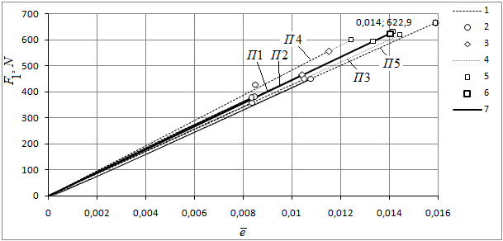
Figure 7. Tension of 1 roving (samples of П1…П5): 1 - according to extensometer; 2 - load shedding; 3 - removal of extensometer; 4 - linear continuation from the condition of proportionality; 5 - limit values the force F₁ and strain ; 6 - the average maximum value; 7 - average dependence of force F₁ from strain.

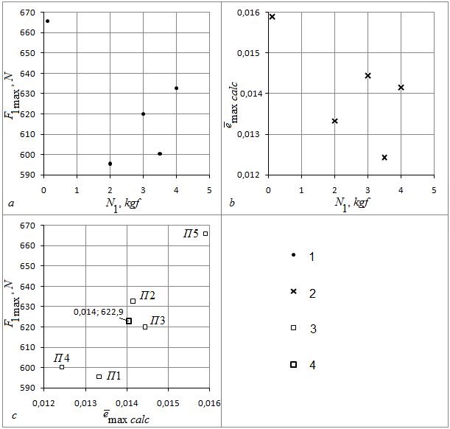
Figure 8. The dependence of the force F_{1max} (applied to 1 roving) - (a) and strain - (b) from the tension of the roving N₁ (see Table 3); F_{1max} from - (c).
1 - fracture force of the preloaded roving; 2 - ultimate strain of preloaded roving; 3 - the force and strain at fracture; 4 - average maximum values.

4. The tensile test of the roving

In addition to the composite test the roving test was conducted (Fig. 9). The test was carried out on machine Instron 8802 using extensometer 2620-601. Measuring base was 52.5 mm, working section length - 140 mm. Temperature during the test + 20 ^{о}С, speed of displacement - 30 mm/min.

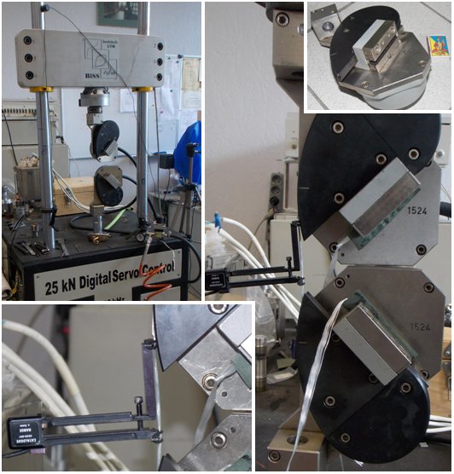
a
b
c
d
Figure 9. Tensile test of roving: a - testing machine Instron 8802; b - extensometer 2620-601 installed on the specimen; c - general view of the roving test; d - the "snail" grip.

As a specimen was used a section of the roving spooled from reel.

Limit values of strains (Table 7) were obtained by calculation and not by direct measurements. Mechanical properties of the roving were determined on the base of test results of specimens P1, P2, P3 (Table 7). Test results of specimens are presented in Figure 11.

The graphical dependency was not available because of instability of extensometer fixation .

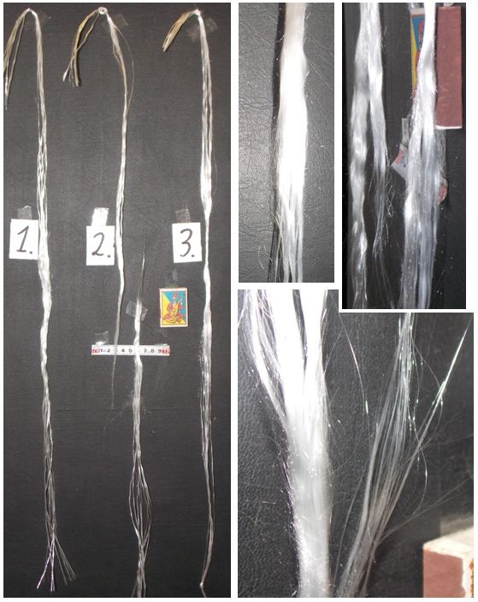
a
b
c
d
Р1
Р2
Р3
Figure 10. Specimens of roving (P1, P2, P3) after tensile testing.

Table 7. The results of the roving tensile test.
# specimen | fracture force,  kN | Max. deformation,  % | Rigidity,  kN/mm¹⁾ | Specimen marking | Place of destruction
1²⁾ | 0.41 | 1.73 | 0.91 |  | in grips
2 | 0.62 | 1.64 | 1.55 | P1 | working part
3 | 0.64 | 1.20 | 0.88 |  | in grips and working part
4 | 0.55 | 1.02 | 1.04 |  | in grips and working part
5³⁾ | 0.66 | - | - |  | working part
6³⁾ | 0.73 | - | - |  | working part
7³⁾ | 0.65 | - | - |  | working part
8 | 0.69 | 1.31 | 1.21 | P2 | working part
9 | 0.6 | 1.70 | - | P3 | working part
Note:
¹⁾ Approximate value;
²⁾ The sample had the original damage;
³⁾ Tests without the use of extensometer.

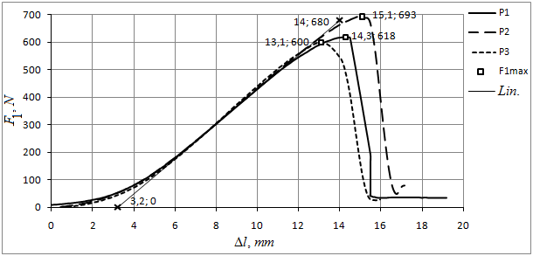
Figure. 11. Dependence of force in specimens P1, P2, P3 from grips displacement Δl. -maximal force during the test; Lin. - linear dependence.

5. Comparison of test results of the roving and composite material

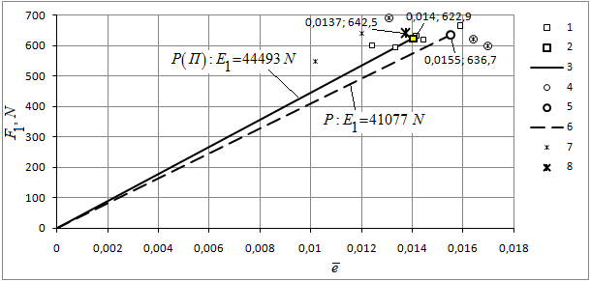
Figure. 12. A summary diagram of tension. Composite test: 1 - limit force F₁ and strain ; 2 - average maximum value; 3 - average dependence . Roving test (specimens P1, P2, P3): 4 - displacement by extensometer; 5 - load-shedding; 6 - extensometer taking-off; all specimens in Table 7 except specimen 1; 8 - average of all data in Table 7.

Table 8. Test results of the roving specimens and roving as component of П1...П5 specimens.
Roving |  |  |  |  | Roving of П1...П5 specimens
Specimen |  |  |  |  | Specimen
P1 | 0.0164 | 620 | 37805 |  | П1 | 0.0133 | 595.5 | 44682
P2 | 0.0131 | 690 | 52672 |  | П2 | 0.0142 | 632.7 | 44715
P3 | 0.0170 | 600 | 35294 |  | П3 | 0.0144 | 620.0 | 42938
 |  |  |  |  | П4 | 0.0124 | 600.3 | 48308
 |  |  |  |  | П5 | 0.0159 | 665.8 | 41878
Average | 0.0155 | 636.7 | 41924 |  | Average | 0.0140 | 622.9 | 44504
 |  |  |  |  | min | 0.0124 | 595.5 | 41878
 |  |  |  |  | max | 0.0159 | 665.8 | 48308

In calculations could be used average values of specimens П1…П5 test data: the limit strain ; the limit force per roving , and from here, .

6. Additional research of the material

Linear density of the roving
A sample of roving with length of 1 m was weighed on Denver Instrument APX-60 (maximum permissible weight 60 g, measuring accuracy 0.1 mg.) Error in finding the length of specimen: ± 1 mm. Results are listed in table 9.

Table 9. Weight of 1 m roving.
№  weighing | 1 | 2 | 3 | 4 | 5 | 6 | 7 | 8 | 9 | Average
Weight, gr. | 1.7214 | 1.7215 | 1.7212 | 1.7214 | 1.7215 | 1.7214 | 1.7214 | 1.7214 | 1.7215 | 1.7214

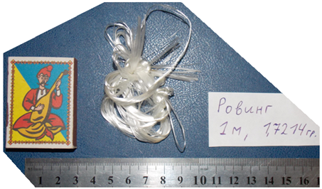
Figure 13. Specimen of the roving with length 1 m, subjected to weighting.

Linear density of roving, according to measurements - 1721.4 teks (according to the certificate (see table 1) - 1760 teks).

Measurement of the cross section of the roving in a free state
The measurement was carried out using a caliper. The following results were obtained: width ~ 5 mm, thickness ~ 0.3 mm. Diameter of twisted roving ~ 1 mm.

Photomicrography of the roving
The pictures were used to determine the diameter of the roving filaments. Based on the results of the measurements filament diameter is ~10 μm. It was noted the transparency of the filaments (Fig. 14).

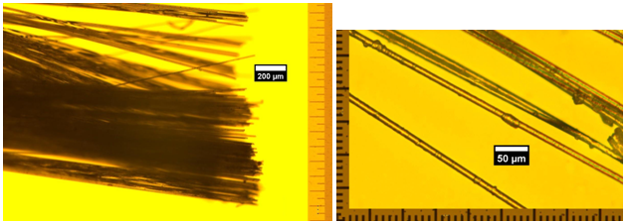
a
b
Figure. 14. Roving filaments (enlarged).

Thermal testing of the composite
After the destruction the elements of samples П1..П5 were subjected to half-hour exposure to different temperatures (Fig. 15). At temperature 250 ^{о}С composite slightly darkens, at 300 ^{о}С it darkens and begins to give off unpleasant smell, at 350 ^{о}С it emits strong smell and starts spilling out.

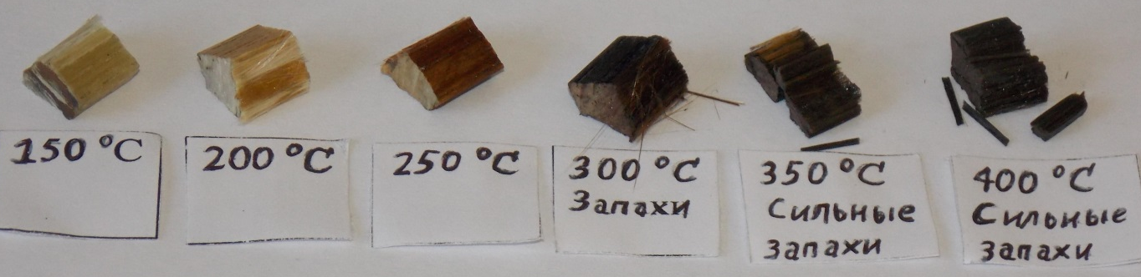
Figure. 15. Elements of the specimens after half an hour exposure excerpts to different temperatures.

Measurement of the cross-sectional area of roving
At dense packing of the roving with tension ~ 5 kg in the groove (cross section 19.2 × 3.1 mm) total number of strands of the roving amounted to 57 (fig. 16). Coming from here, the cross-sectional area of the roving in wrapped state - .
Assuming that the cross section of the filament is 6-sided polygon of 10 microns diameter we would obtain cross-sectional area of the roving (1200 filaments) 0.416 mm² - most dense packing. In this case the groove could be filled up by 143 strands. The discrepancy between the practical and the theoretical density of packing is most likely be explained by real form of cross section of the filaments (fig. 14b), the presence of lubricant and insufficient stress tension during laying. For the complete straightening of the filaments of the roving applied tension should be 150...200 N (Fig. 11).
Note that average area per 1 roving of the specimens was at sections: (а), (б) - 1.36 mm²; (c), (d) - 0.96 mm²; (e), (f), (g), (h) - 0.92 mm² (Fig. 3).

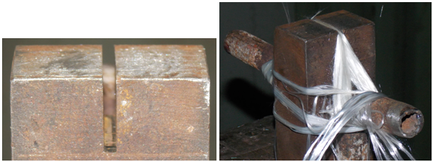
a
b
Figure. 16. Laying of roving in the groove: a - groove cross-section 19.2 × 3.1 mm; b - roving, laid into the groove.

7. Properties of the filler material

According to the data provided by MPRI NASB in the calculations, could be used the following (approximate) characteristics of filler:

-Young's modulus: 1.8-2.2 HPa;
-yield strength: 80 MPa;
-Poison’s ratio: 0.25
-impact strength 15 kJ/m².
-density: 1000-1100 kg/m³.

8. List of references

1. TU UA 24.6-0030314547-002-2004- Epoxy resin КДА - ХИ. (ТУ У 24.6-0030314547-002-2004 - Связующее эпоксидное марки КДА - ХИ).
2. GOST 17139-2000-Fiberglass. Roving. Specification. Minsk. (ГОСТ 17139-2000 - Стекловолокно Ровинги Технические условия. Минск).
3. Gutnikov S. I., Lazorak B. I., Seleznyov A. N. Glass fibers: Handbook for students studying in composite nanomaterials. -M., 2010. -53 s. (Гутников С. И., Лазоряк Б. И., Селезнев А. Н. Стеклянные волокна : учеб. пособие для студентов по специальности «Композиционные наноматериалы». - М., 2010. - 53 с).
4. GOST 6943.10-79 - Textile glass. Method for determination of breaking load and elongation at break. (ГОСТ 6943.10-79 - Материалы текстильные стеклянные. Метод определения разрывной нагрузки и удлинения при разрыве.).

